Contents

1. Grammatical accuracy and Lexical Resource accuracy 2

**Strategy: Know your ‘favourite’ mistakes** 2

**Strategy: Secret mission** 2

**Strategy: Find out about the theory** 2

**Strategy: Is this the way I would express this idea?** 2

**Activity: Dictogloss** 2

**Activity: Two-way translation** 2

**Activity: Grammar spotting** 2

**Activity: Learn to understand problematic grammar in real speech using TubeQuizard** 3

2. Lexical Resource range 4

**Strategy: Set a daily target** 4

**Strategy: How to choose words?** 4

**Strategy: Which words are top priority?** 4

**Strategy: How to record vocabulary?** 6

**Strategy: Use dictionaries to find collocations** 7

**Strategy: How to memorize vocabulary** 7

3. Grammatical Range 8

**Strategy: Use them or lose them** 8

4. Discourse management 8

**Strategy: Find out about the theory about structuring your speech** 8

**Activity: 4-3-2** 9

**Strategy: Functions hunting** 9

5. Pronunciation 10

**Activity: Find out about the way English sounds change in fast speech** 10

**Activity: Learn to pronounce aspirated /p/, /t/, /k/** 10

**Activity: Use voice recognition software to learn to pronounce English sounds** 10

**Activity: Shadowing** 10

6. Interaction 11

**Strategy: Interaction hunting** 11

7. Useful links 12

# 1. Grammatical accuracy and Lexical Resource accuracy

**Aims:**

* **get rid of basic grammar mistakes that you often make**
* **stop choosing incorrect words, e.g. making collocations mistakes (for example, learn that you need to say ‘*take a picture’* – NOT ‘*~~make~~’*)**

**Strategy: Know your ‘favourite’ mistakes**Create a list of mistakes that you frequently make (write them down when your teacher corrects you or when you self-correct).

### **Strategy: Secret mission**

Before a class, choose which mistake to concentrate on. Self-correct only this mistake type during the whole class. You can also do the same out of class when you’re speaking to yourself (*shower conversations*).

**Strategy: Find out about the theory**If you make some of your ‘favourite’ mistakes because you don’t know the rules, read or watch a short video about the rules.

Links:  
1. <https://dictionary.cambridge.org/grammar/> Cambridge grammar  
2. Engvid – useful videos on YouTube (example search: ‘[Engvid Present Perfect’](https://www.youtube.com/results?search_query=Engvid+present+perfect)).

### **Strategy: Is this the way I would express this idea?**

When you’re reading or watching something, ask yourself: would I express the same idea in the same way, or would I use different words and grammar? This will help you to notice interesting expressions that sound simple but that you’re not using yet. You will also notice that you might be using incorrect word combinations.

### **Activity: Dictogloss**

Watch a video. Watch a short extract one more time (15-20 seconds) and write down 5-7 expressions while you're watching (don't stop the video!) Try to reconstruct the text using the expressions. Then compare with the transcript and analyze the differences.

|  |
| --- |
| **NB**: To make sure your video has subtitles, add ‘, cc’ to your YouTube search, e.g. ‘[Paul Irish interview, cc](https://www.youtube.com/results?search_query=Paul+Irish+interview%2C+cc)’. |

### **Activity: Two-way translation**

Choose a short text in English (4-10 sentences). Translate it into your native language. Cover the English text and translate your translation back into English. Compare with the original text and analyze the differences.

|  |
| --- |
| **NB**: **Dictogloss** and **Two-way translation** are especially good for articles, prepositions, etc. They will be especially useful after you’ve read or watched about the rules on these topics. |

**Activity: Grammar spotting**   
Watch a video. Try to write down all the examples of the target grammar (e.g. all examples when the speaker uses 3rd person -s in Present Simple). Check your answers using the transcript. Write a summary of the video using the target grammar. Record yourself retelling the summary and paying attention to the target grammar.

|  |
| --- |
| If your target grammar is not very frequent, you can use <http://tubequizard.com/search.php> to look for short subtitled videos that contain examples of this grammar:  Choose grammar topic using the ‘Grammar for listeners’ filter. |

### **Activity: Learn to understand problematic grammar in real speech using TubeQuizard**

If **Grammar spotting** is difficult for you because you can’t hear the examples of grammar in real speech, you can use the ‘Train with your video’ feature on <http://tubequizard.com/> to train yourself to hear grammar. This tool generates ‘Grammar for listeners’ quizzes based on any subtitled YouTube video.

Here is a sample set of quizzes generated from a video (<http://tubequizard.com/auto_quizzes.php?v=EtQ8Le8-zyo>):

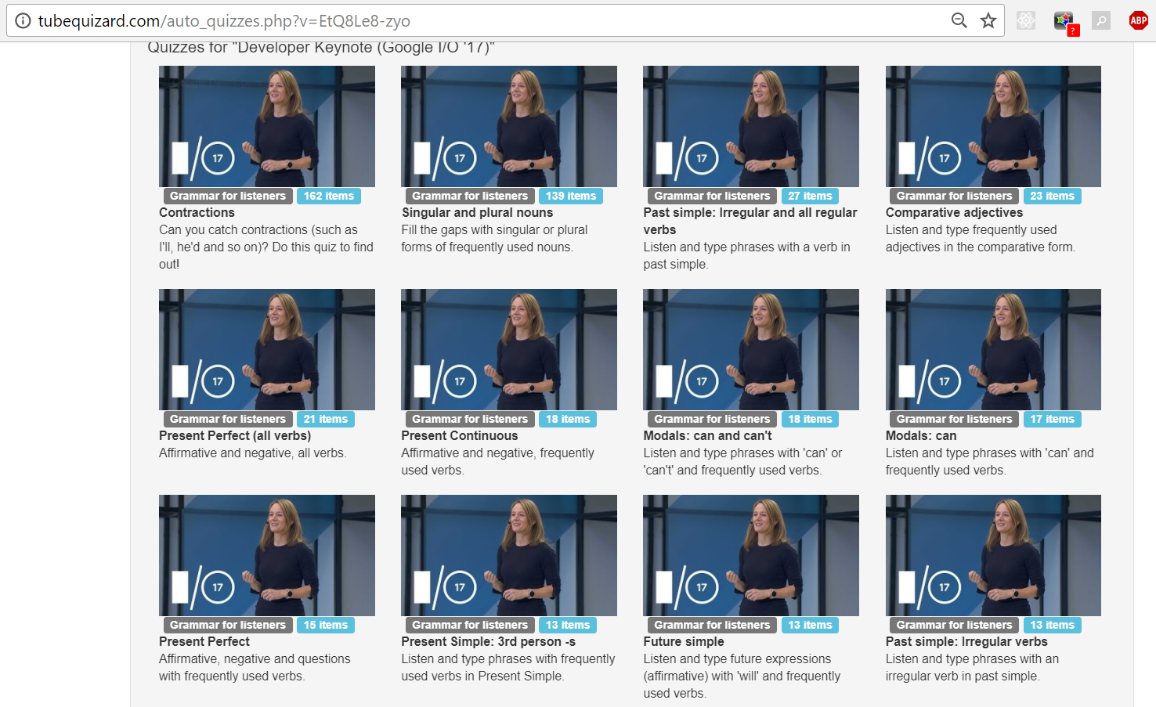

You can use the following process:

1. Choose a subtitled video that you like (see some suggestions in the last section on **Useful links**).
2. Turn off the subtitles (and keep them turned off). Watch about 5 minutes for fun.
3. Create listening quizzes based on your video using [TubeQuizard](http://www.tubequizard.com/add_quiz.php) and do a few quizzes.
4. Finally, watch the whole video.

2. Lexical Resource range  
**Aims:**

* **learn and start using more advanced vocabulary**

### **Strategy: Set a daily target**

Decide how many words (or collocations / expressions) you’d like to learn every day (even 2–5 words a day will sum up to 60–150 words a month!) Find these words in things that you read or watch in English (including meetings and work emails, StackOverflow forums, etc.) **Don’t try to learn more.**

### **Strategy: How to choose words?**

Here are some ideas what words you could choose:

|  |
| --- |
| **How to CHOOSE vocabulary** |
| 1. Choose the words you have already seen several times but you are still not sure about |
| 2. Choose old words you see used in new ways |
| 3. Choose collocations |
| 4. Choose the words you need but don’t know while you speak or write (in class or out of class) – **always have a notebook with you where you’ll record these words!** |
| 5. Choose only the most frequent words (see the next strategy) |
| 6. When choosing words, think in which situations you will need them (can you imagine a sentence with a word that you can say in some situation?) |

### **Strategy: Which words are top priority?**

Which words are the most useful? The highest frequency words that you don’t know yet.  
You can use special software to find out which words in the text you’re reading (or in the video, if it has subtitles) are high frequency. If you don’t know some of these words, they should be your priority number one.

<https://www.lextutor.ca/vp/eng/> uses colours to show word frequency:

|  |  |
| --- | --- |
| blue: TOP 1000 green: 1001 – 2000 | yellow: academic vocabulary red: not in the top 2000 |

Text inspector <http://englishprofile.org/wordlists/text-inspector> categorizes words by level (A1/A2/B1/B2/C1/C2).

**Example**. I took this text from **economist.com** and analyzed it with these two tools.

|  |
| --- |
| *IN 2016 Lee Sedol, one of the world’s best players of Go, lost a match in Seoul to a computer program called AlphaGo by four games to one. It was a big event, both in the history of Go and in the history of artificial intelligence (AI). Go occupies roughly the same place in the culture of China, Korea and Japan as chess does in the West. After its victory over Mr Lee, AlphaGo beat dozens of renowned human players in a series of anonymous games played online, before re-emerging in May to face Ke Jie, the game’s best player, in Wuzhen, China. Mr Ke fared no better than Mr Lee, losing to the computer 3-0.* |

<https://www.lextutor.ca/vp/eng/> returned this:

|  |
| --- |
| in number lee sedol one of the world best players of go lost a match in seoul to a computer program called alphago by four games to one it was a big event both in the history of go and in the history of artificial intelligence ai go occupies roughly the same place in the culture of china korea and japan as chess does in the west after its victory over mr lee alphago beat dozens of renowned human players in a series of anonymous games played online before re emerging in may to face ke jie the game best player in wuzhen china mr ke fared no better than mr lee losing to the computer number |

It also gives you a list of words from the text, categorized by frequency. It is very easy to look through the list and check if there are words that you don’t know.

|  |
| --- |
| **0-1000** a a a a after and and as before best best better big both by called does event face four game games games go go go history history human in in in in in in in in in it its losing lost may mr mr mr no number number of of of of of of of one one over place played player players players re roughly same than the the the the the the the the to to to to victory was west world  **First 500 content (26)**: best best better big called event face game games games go go go losing lost number number one one place played player players players same world  **Second 500 content (12)**: both four history history human mr mr mr re roughly victory west  **1001-2000** artificial beat dozens match program  **AWL** [academic vocabulary list] computer computer culture emerging intelligence occupies series  **OFF LIST** ai alphago alphago anonymous chess china china fared japan jie ke ke korea lee lee lee online renowned sedol seoul wuzhen |

Text inspector returned this:

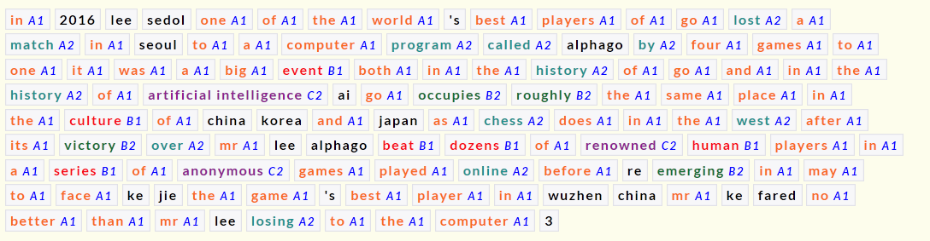

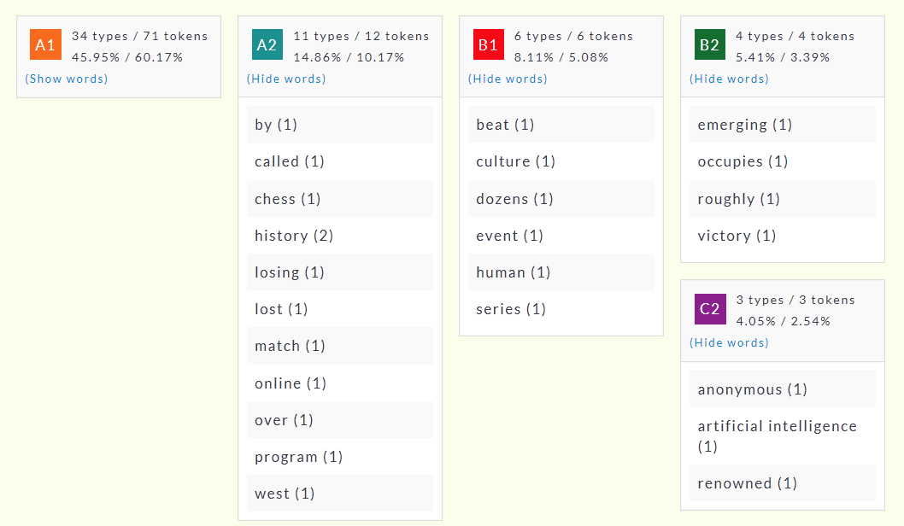

### **Strategy: How to record vocabulary?**

|  |
| --- |
| There are two most important principles:  You need to log the words that you learn and revise them from time to time.  The way you record vocabulary should make it possible to recall the word (*вспомнить*). If you simply re-read the word, this is much less effective!  For example you could record your words in the sentences in which you noticed them – notice that there are gaps, so you can cover the second column and recall the words: |

You can experiment with these ideas:

|  |
| --- |
| **How to RECORD vocabulary** |
| 1. Translate the word/collocation into your native language |
| 2. Write an English explanation |
| 3. Write the transcription (e.g. mark the stress, difficult sounds) |
| 4. Write a sentence with the word/collocation |
| 5. Write collocations with the word (e.g. to run/manage/make a website |

### **Strategy: Use dictionaries to find collocations**

When you’re writing something, use dictionaries to look for verbs and adjectives that should be used with the nouns you want to use.   
  
**Useful links:**<http://ozdic.com/> gives you lots of collocations to choose from.   
English-English dictionaries give you the most frequent collocations **in the examples** section**.** Here’s a sample from <http://dictionary.cambridge.org/>**.** What collocations can you find in these examples? 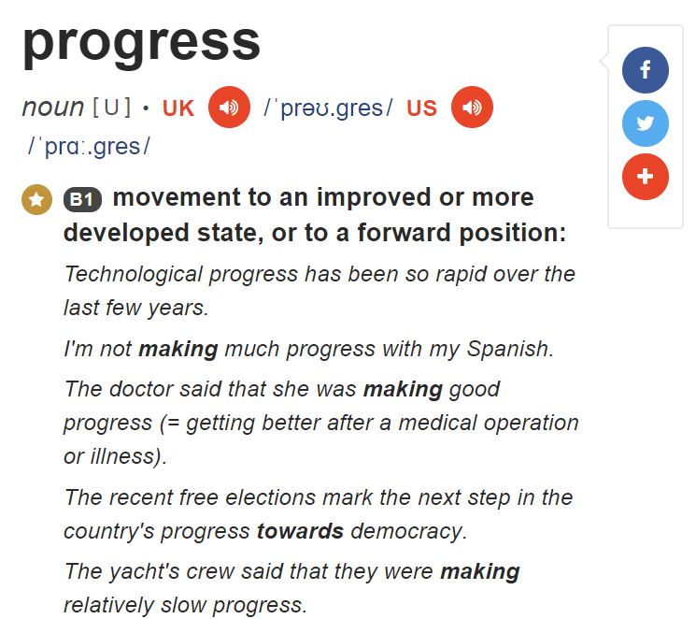

You could record these collocations like this:

|  |  |
| --- | --- |
| progress | I’m | not making much | _______  | making good/slow | |

### **Strategy: How to memorize vocabulary**

|  |
| --- |
| **How to MEMORISE vocabulary** |
| 1. Make online flashcards (we recommend <http://quizlet.com>or anki) |
| 2. Make words cards (pieces of paper) |
| 3. Make mind maps for groups of words that are connected or collocations |
| 4. Make sentences about yourself |
| 5. Make gap-fill exercise and other quizzes with the new words using some online tools |
| 6. Google the words and read some articles about them |
| 7. Teach the words/collocations to another student |
| 8. Talk to someone using the new words |
| 9. Just remember the word and its translation |

3. Grammatical Range

### **Strategy: Use them or lose them**

Before a class, choose a grammar structures and words that you want to start using. Set a goal, e.g. ‘I want to use 2nd conditional 5 times during speaking activities’.

Here’s a sample secret mission checklist that was created by a student:

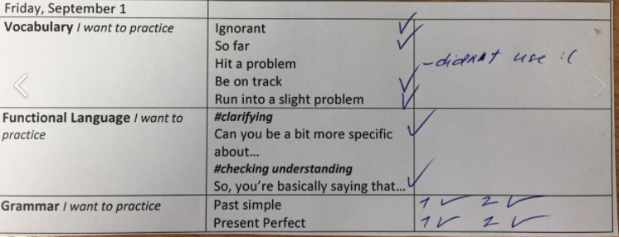

You can also set goals to use specific grammar and expressions (especially functional language) in workplace communication.

4. Discourse management   
**Aims:**

* **learn to give long (1-2 minute) monologues that are easy to follow**
* **learn a range of functional expressions for listing, giving examples, talking about reasons and effects, etc.**
* **increase the speed with which I speak**
* **stop making pauses when I don’t remember a word**

### **Strategy: Find out about the theory about structuring your speech**

There are two useful sources of information on structuring your speech: business advice and exam preparation materials. Business advice videos and articles give advice on how to use so-called ‘speaking frameworks’ to structure your speech. For example, when you’re in a meeting you could use the **PREP** framework (give a **Point**, support it with **Reason,** give an **Example,** and then summarize your **Point).**

Exam preparation materials also give you examples of expressions you can use to give reasons, examples, etc.

**Business advice:**

|  |  |
| --- | --- |
| Matt Abrahams, a communication coach, speaks about how ‘**the key to successful spontaneous speaking is having a structure**’. Watch this extract from his talk, in which he talks about 2 very useful structures. | <https://youtu.be/HAnw168huqA?t=38m37s> (up to 42:39) |
| The STAR framework (for answering customer interview questions about past situations) | <https://www.youtube.com/watch?v=-FMB6xtQdjM> **(**13 minutes) |

**Exam preparation sources:**

|  |  |
| --- | --- |
| IELTS Speaking test: Extending your answers – Spotlight on IELTS | <https://www.youtube.com/watch?v=laeFcs731Vw> |
| How to extend answers in part 1 speaking | <http://www.dcielts.com/ielts-speaking/extend-answers-in-part-1-speaking/> |
| Easy Ways to Extend Your Part 1 Answers | <https://www.ieltsadvantage.com/2015/10/15/extending-ielts-part-1-answers/> |

### **Activity: 4-3-2**

Watch an interesting video or read an article.   
After that, retell it in 4 minutes. Retell it one more time in 3 minutes. Your goal is to speak faster, so try not to leave out any information. Finally, retell it in 2 minutes, speaking even faster (you can record this final version).

|  |
| --- |
| You can combine this activity with **Setting daily targets** and **Use them or lose them** (choose 2-5 expression from the article that you’d like to learn. Make sure you use these expressions while retelling the article). |

### **Strategy: Functions hunting**

When you’ve learnt the theory about structures, you can start noticing them in real life.   
Find a video extract in which someone suggests a solution, or talks about their favourite technology, or describes their project, etc. Look at the transcript and analyze

* what is the structure of their speech?
* What linking expressions do they use?

Example. In this [video](https://www.youtube.com/watch?v=0AzjJIRKHeA) (4 minutes) a developer talks about a UX design problem they had and how they solved it. Watch the video. Then look through the transcript and find the elements of the STAR framework (see the previous strategy). Pay attention to the linkers and the tenses she uses.

|  |
| --- |
| Combine this strategy with **Use it or Lose it** – come to class with a list of functional expressions you’d like to use. |

5. Pronunciation

**Aims**:

* **learn to pronounce English Sounds correction**
* **learn to use sentence stress and intonation effectively**

### **Activity: Find out about the way English sounds change in fast speech**

Watch Tim’s Pronunciation Workshop, an award-winning set of short videos that was produced by BBC Learning English. These videos explain clearly how words and sounds change in fast speech, and provide you with lots of examples and some useful practice.

[Link](https://www.youtube.com/watch?v=psI7E_J1zPo&list=PLcetZ6gSk96-ayXj5thbTpbh2vHWpP08o) (or type ‘Tim’s pronunciation workshop’ into YouTube search).

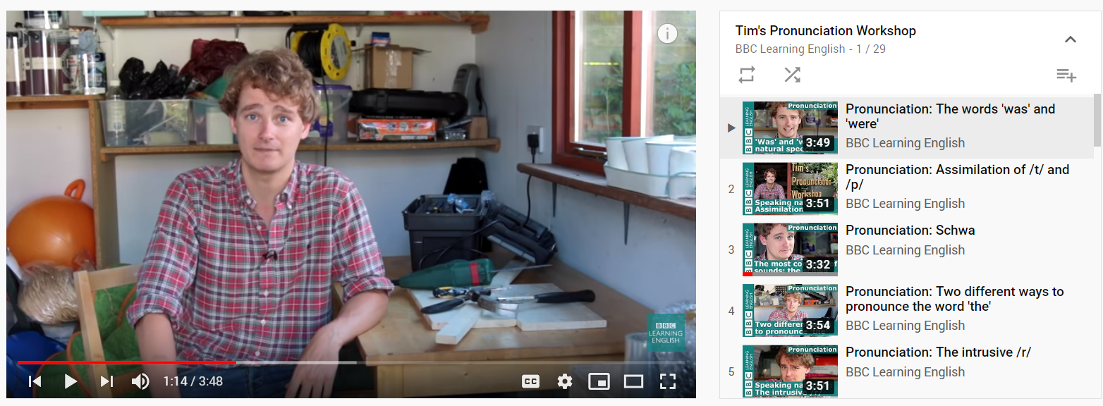

### **Activity: learn to pronounce aspirated /p/, /t/, /k/**

Research show that if you don’t aspirate /p/, /t/ and /k/, native speakers of English may mishear them as /b/, /d/ and /g/. E.g. when you say ‘pin’, they might hear ‘bin’.

Use these videos to find out how to produce aspirated /p/, /t/, /k/ and to get a bit of practice. <https://www.youtube.com/watch?v=6PSdlctYBsw>   
<https://www.youtube.com/watch?v=xe6MIo816jo>

### **Activity: Use voice recognition software to learn to pronounce English sounds**

**Stage 1: diagnostics**

Pick a tongue twister from this list: <https://www.engvid.com/english-resource/50-tongue-twisters-improve-pronunciation/>

Dictate the tongue twister into voice recognition software, e.g. the voice assistant on your phone. If the software recognizes some of the words incorrectly, analyze which sound you mispronounced.

**Stage 2: practice**

Use the videos at the bottom of the page show how to find out how to pronounce English sounds: <http://www.bbc.co.uk/learningenglish/features/pronunciation>

Stage 3: test

Repeat stage 1 to see if the software recognizes your speech better.

### **Activity: Shadowing**

In this activity you choose a video with a transcript, choose a short extract (15-60 seconds) and learn to repeat everything that the speaker says with the same speed and intonation.

You could ask your teacher to try this activity in class – if you don’t want to wait, here are the instructions.

Preparation:

1. Listen / watch the recording for gist.
2. Distribute transcripts or students transcribe several sentences from the recording.
3. Analyze 10-20 seconds of the recording for pauses, tonic and sentence stress and weak forms.   
   Mark up, on the board and in the transcripts.

Shadowing:

1. Read the script with the correct intonation.
2. Read sentence by sentence: read one a sentence, take your eyes off the transcript and say the sentence.
3. Listen and repeat sentence by sentence.
4. Listen and repeat together with the speaker.

6. Interaction  
**Aim: learn to create a ‘friendly’ relationship with the person you’re talking to**

### **Strategy: Interaction hunting**

When you’re in a meeting (or when you’re watching videos such as interviews), pay attention to ‘short’ replies and expressions that speakers use to create a friendly atmosphere and sound friendly and polite.

|  |
| --- |
| Combine this strategy with **Use it or Lose it** – come to class with a list of functional expressions you’d like to use. |

# 7. Useful links

|  |
| --- |
| The best way to use the resources in this section is to aim for a balance of fun and purpose: choose resources that you like, but also choose a couple of strategies that will guarantee that you’ll make some progress. For example, you can watch Lost because you like this show, but you can have the goal of learning 2 expressions from each episode. Then by the end of the series you know 250 new expressions, which is a very good result. |

Here are some resources that we particularly recommend.  
  
**Resources for language learners**

[**Six minute English**](http://www.bbc.co.uk/learningenglish/english/features/6-minute-english)

A BBC Learning English service that offers 6 minute podcasts. Each video comes with a list of vocabulary and the transcript. Sometimes, there are also comprehension questions.

[**British Council LearnEnglish**](http://learnenglishteens.britishcouncil.org/skills/listening-skills-practice)

Short videos on different topics, with tasks – useful for organizing self-study.

[**TED Ed**](https://ed.ted.com/lessons/)

Video-based lessons on a range of topic (business, technology, literature, arts, etc).

[**Puzzle English**](https://puzzle-english.com/)

Training on listening comprehension, grammar and vocabulary

**Authentic resources**

**Reading**

[**Quora.com**](http://quora.com)

This is very popular question and answer service. Some threads feature lots of stories (e.g. 'What's the craziest thing you've ever done?'), some give insight into culture (e.g. topics like 'What is acceptable in the USA but not in the UK?') and some are just factual.

**YouTube: IT channels**

[**Google developers**](https://www.youtube.com/user/GoogleDevelopers)

Some interesting videos on this channel: [**Coffee with a Googler**](https://www.youtube.com/user/GoogleDevelopers/search?query=coffee+with+a+googler) – a series of interviews with Google employees who talk about their projects.

[**Android developers**](https://www.youtube.com/user/androiddevelopers)   
Some interesting videos on this channel: a show called [Android design in action](https://www.youtube.com/watch?v=eEU3t0x_pxQ&list=PLWz5rJ2EKKc8j2B95zGMb8muZvrIy-wcF) (a show in which three designers look at mobile apps and discuss how the design of the apps could be improved). Please be careful because not all videos on this show are in sync with the subtitles.

**YouTube Business English channels**[**How to start a start-up**](https://www.youtube.com/channel/UCxIJaCMEptJjxmmQgGFsnCg/videos) – a series of 20 lectures with people who started successful IT start-ups sharing their stories and their tips. These lectures might well be the best lectures ever on starting a start-up, and I’d say they are interesting even for those people who isn’t planning to start a company.

[**Stanford School of Business**](https://www.youtube.com/user/stanfordbusiness) – a channel that features interviews with CEOs of large companies. Look for the longer (~50 min) videos with this backdrop:

Some interesting videos on this channel:

* An interview with the person who started TGI Fridays: <https://www.youtube.com/watch?v=nZlvs7IKSkA>
* A talk by Matt Abrahams, a communication expert, on communication techniques: <https://www.youtube.com/watch?v=HAnw168huqA>

**YouTube: general English talks and interviews**  
Tip: sort the videos on the channel by popularity.

[**Talks at Google**](https://www.youtube.com/user/AtGoogleTalks)

Some interesting videos on this channel:

* Daniel Pink (the speaker who gave one of the 10 most viewed TED talks of all times) <https://www.youtube.com/watch?v=9j2aTwNor5k>
* Daniel Kahneman (a psychologist, a Nobel prize winner in Economics explores where we can and can’t trust our intuitions)  
  <https://www.youtube.com/watch?v=CjVQJdIrDJ0>

[**TED talks**](https://www.youtube.com/channel/UCAuUUnT6oDeKwE6v1NGQxug)

[**KurzGesagt – In a nutshell**](https://www.youtube.com/user/Kurzgesagt/videos)

A great educational channel with short (5-10 min) videos on a range of general interest topics, with amazingly beautiful animation.

[**Toronto public library**](https://www.youtube.com/user/torontopubliclibrary) - a Canadian channel that features interviews with book writers and other public figures, both from Canada and other countries.